**I OT Assignment-14**

(Dheeraj Tiwari)

1. When the tilt of the sensor is detected, the buzzer and LED should get triggered by Arduino.

Ans :

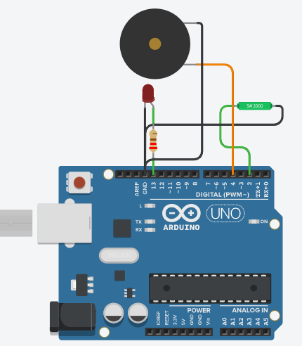

const int ledPin = 13;

const int swTilt = 2;

const int buzzPin=4;

int val = 0;

void setup(){

Serial.begin(9600);

pinMode (ledPin, OUTPUT);

pinMode (buzzPin, OUTPUT);

pinMode (swTilt, INPUT_PULLUP);

}

void loop(){

val = digitalRead(swTilt);

if (val == LOW) {

digitalWrite(ledPin,HIGH);

digitalWrite(buzzPin,HIGH);

Serial.println("Tilted");

}

else {

digitalWrite(ledPin,LOW);

digitalWrite(buzzPin,LOW);

Serial.println("NOT TILTED"); }}

1. Perform an experiment to display some text strings on Serial monitor and operate buzzer when TMP36 Sensor Values in deg Celsius
   1. <20-Cold
   2. >20 and <30-Average
   3. >30 and <50 –Hot
   4. >50- Buzzer should rang

Ans : 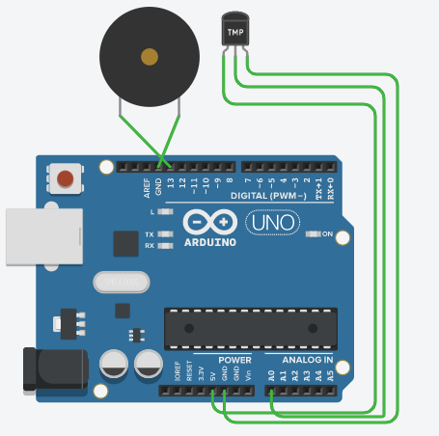

int sensorPin = A0;

int celsius=0;

double temp;

void setup() {

Serial.begin(9600);

pinMode(13,OUTPUT);

}

void loop() {

celsius = map(((analogRead(sensorPin) - 20) * 3.04), 0,

1023, -40, 125);

Serial.print("Temp: ");

Serial.print(celsius);

Serial.println(" *C");

if(celsius < 20){

Serial.println("Cold");

digitalWrite(13,LOW);

}else if (celsius >20 and celsius <30){

Serial.println("Average");

digitalWrite(13,LOW);

}else if (celsius >30 and celsius <50){

Serial.println("Hot");

digitalWrite(13,LOW);

}else if(celsius > 50){

digitalWrite(13,HIGH); }}

1. Perform an experiment using TMP36 sensor, DC motor & LED

* If the temperature >30, Turns ON the motor
* If the temperature <30, Turns OFF the motor and Turns on the LED

ANS :

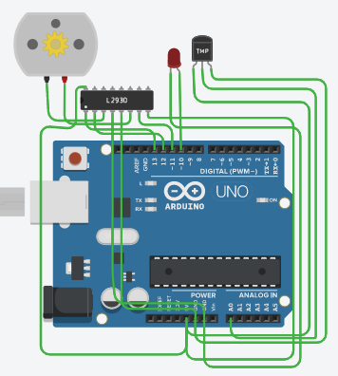

int sensorPin = A0;

int celsius=0;

double temp;

void setup() {

Serial.begin(9600);

pinMode(13,OUTPUT);

pinMode(12,OUTPUT);

pinMode(11,OUTPUT);

pinMode(10,OUTPUT);

Serial.begin(9600);

digitalWrite(13,HIGH);

}

void loop() {

celsius = map(((analogRead(sensorPin) - 20) * 3.04), 0,

1023, -40, 125);

Serial.print("Temp: ");

Serial.print(celsius);

Serial.println(" *C");

if(celsius > 30 ){

digitalWrite(12,LOW);

digitalWrite(11,HIGH);

digitalWrite(10,LOW);

delay(100);

}else{

digitalWrite(12,HIGH);

digitalWrite(11,HIGH);

digitalWrite(10,HIGH);

delay(100);}}

1. What is Flame Sensor and Write an application of Flame Sensor?

Ans :

* A flame sensor module that consists of a flame sensor (IR receiver), resistor, capacitor, potentiometer, and comparator LM393 in an integrated circuit. It can detect infrared light with a wavelength ranging from 700nm to 1000nm.The far-infrared flame probe converts the light detected in the form of infrared light into current changes. Sensitivity is adjusted through the onboard variable resistor with a detection angle of 60 degrees.
* A flame detector is a sensor designed to detect and respond to the presence of a flame or fire. Responses to a detected flame depend on the installation, but can include sounding an alarm, deactivating a fuel line (such as a propane or a natural gas line), and activating a fire suppression system.
* Working voltage is between 3.3v and 5.2v DC, with a digital output to indicate the presence of a signal. Sensing is conditioned by an LM393 comparator.

**Application of Flame Sensor:**

* Hydrogen stations
* Combustion monitors for burners
* Oil and gas pipelines
* Automotive manufacturing facilities
* Nuclear facilities
* Aircraft hangars
* Turbine enclosures

1. Perform an experiment to interface Flame sensor with Arduino so that when flame is detected buzzer should turn on and when flame is not detected relay should get activated and turns on AC Bulb.